Q1.
<!DOCTYPE html>
<html lang="en">
<head>
<meta charset="UTF-8">
<meta name="viewport" content="width=device-width, initial-scale=1.0">
<title>Table and Image Animation</title>
<style>
/* Basic Styling */
body {
font-family: Arial, sans-serif;
text-align: center;
padding: 50px;
}

table {
margin: 20px auto;
border-collapse: collapse;
width: 300px;
}

td {
padding: 10px;
border: 1px solid #ddd;
}

/* Alternate Row Colors */
tr:nth-child(odd) {
background-color: #f2f2f2;
}

tr:nth-child(even) {
background-color: #e2e2e2;
}

img {
width: 150px;
height: auto;
margin: 20px auto;
display: block;
}

/* Container for table and image to move together */
.move-container {
display: inline-block;
}
</style>
<!-- jQuery Library -->
<script src="https://code.jquery.com/jquery-3.6.0.min.js"></script>
<script>
$(document).ready(function() {
$('#moveButton').click(function() {
// Move the container (table and image) from right to left
$('.move-container').animate({
left: '-50%' // Move the element 100% to the left
}, 2000); // Duration of the animation in milliseconds
});
});
</script>
</head>
<body>

<h1>Table and Image Animation</h1>
<!-- Move Container that holds the table and image -->
<div class="move-container" style="position: relative;">
<!-- Table with 3x3 dimensions -->
<table>
<tr>
<td>Arun</td>
<td>60</td>
<td><img src = "./arnu.jpeg"></td>
</tr>
<tr>
<td>Anita</td>
<td>58</td>
<td><img src = "./anita.jpeg"></td>
</tr>
<tr>
<td>Anku</td>
<td>27</td>
<td><img src = "./anku.jpeg"></td>
</tr>
</table>

<!-- Image -->
</div>

<!-- Button to Trigger the Animation -->
<button id="moveButton">Move Table & Image</button>

</body>
</html>
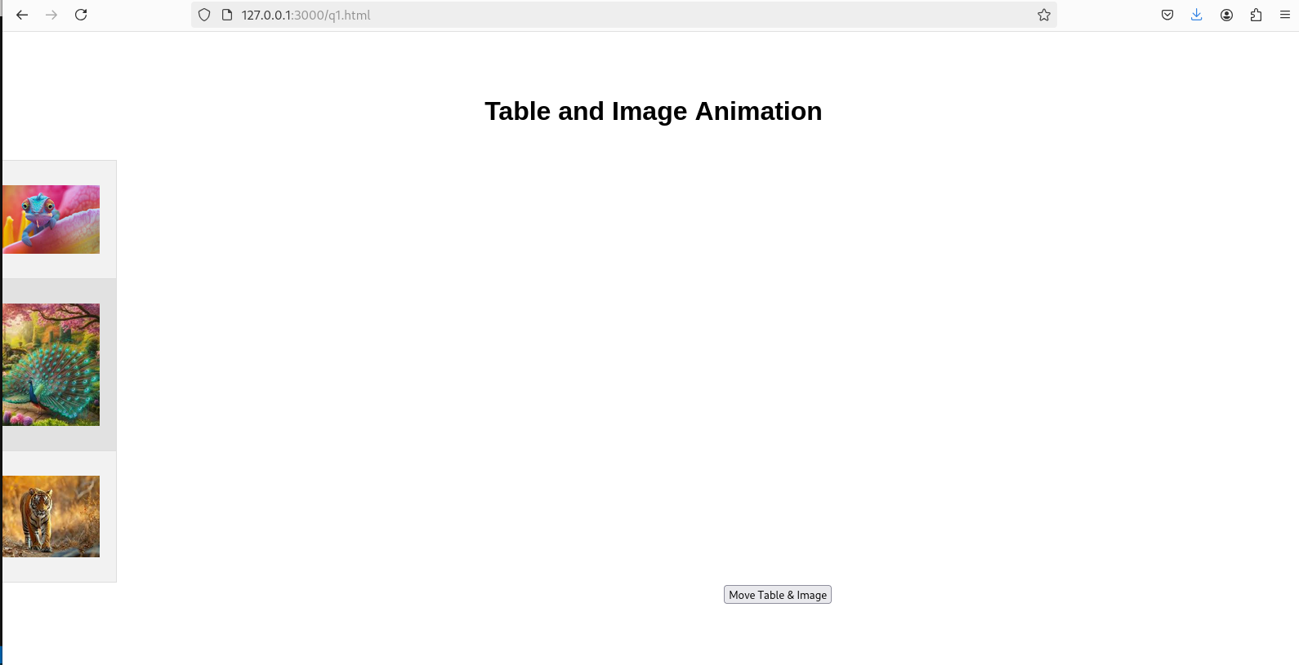

Q2.
<!DOCTYPE html>
<html lang="en">
<head>
<meta charset="UTF-8">
<meta name="viewport" content="width=device-width, initial-scale=1.0">
<title>Simple Calculator</title>
<style>
/* Basic Styling for Calculator */
body {
font-family: Arial, sans-serif;
text-align: center;
margin-top: 50px;
}

.calculator {
display: inline-block;
border: 2px solid #ccc;
padding: 20px;
border-radius: 10px;
box-shadow: 0px 0px 15px rgba(0, 0, 0, 0.1);
}

input[type="text"] {
width: 220px;
height: 40px;
text-align: right;
font-size: 18px;
margin-bottom: 20px;
padding: 10px;
border-radius: 5px;
border: 1px solid #ccc;
}

button {
width: 50px;
height: 50px;
font-size: 20px;
margin: 5px;
border-radius: 5px;
border: 1px solid #ccc;
cursor: pointer;
transition: background-color 0.3s;
}

button:hover {
background-color: #f1f1f1;
}

.row {
margin-bottom: 10px;
}
</style>
<!-- jQuery Library -->
<script src="https://code.jquery.com/jquery-3.6.0.min.js"></script>
<script>
$(document).ready(function() {
// Variable to hold current value being typed
let currentInput = '';

// When number or operator is clicked
$('.button').click(function() {
currentInput += $(this).text(); // Add the value of the clicked button to currentInput
$('#display').val(currentInput); // Update the display with currentInput
});

// When Clear button is clicked
$('#clear').click(function() {
currentInput = '';
$('#display').val(currentInput); // Clear the display
});

// When Equal button is clicked
$('#equals').click(function() {
try {
currentInput = eval(currentInput).toString(); // Evaluate the current expression
$('#display').val(currentInput); // Display the result
} catch (e) {
$('#display').val('Error'); // If there's an error, show error
currentInput = '';
}
});
});
</script>
</head>
<body>

<div class="calculator">
<h2>Calculator</h2>
<!-- Display for input/output -->
<input type="text" id="display" disabled />

<!-- Calculator Buttons -->
<div class="row">
<button class="button">7</button>
<button class="button">8</button>
<button class="button">9</button>
<button class="button">/</button>
</div>
<div class="row">
<button class="button">4</button>
<button class="button">5</button>
<button class="button">6</button>
<button class="button">*</button>
</div>
<div class="row">
<button class="button">1</button>
<button class="button">2</button>
<button class="button">3</button>
<button class="button">-</button>
</div>
<div class="row">
<button class="button">0</button>
<button class="button">.</button>
<button id="equals">=</button>
<button class="button">+</button>
</div>
<div class="row">
<button id="clear">C</button>
</div>
</div>

</body>
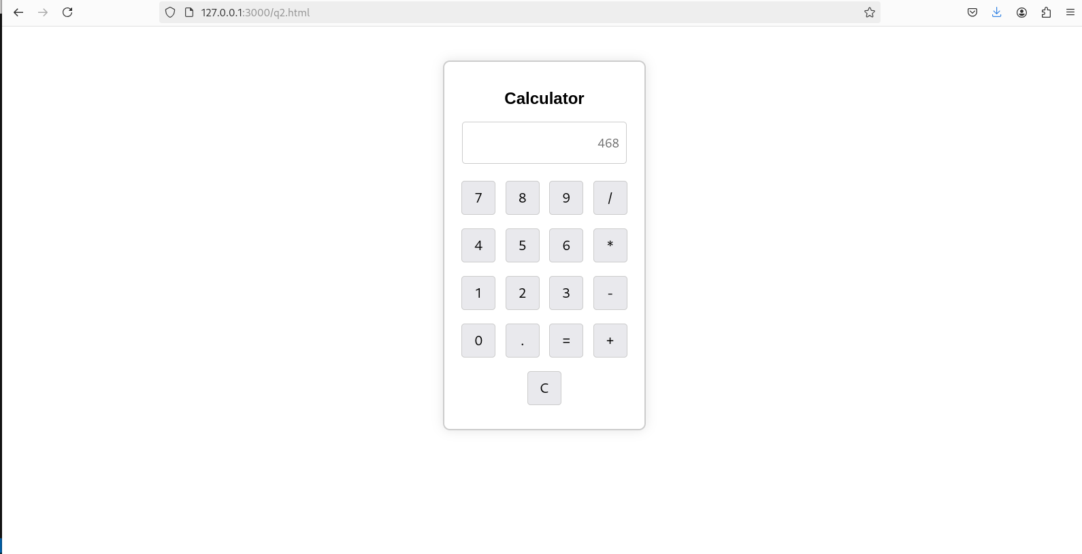
</html>

Q3.
<!DOCTYPE html>
<html lang="en">
<head>
<meta charset="UTF-8">
<meta name="viewport" content="width=device-width, initial-scale=1.0">
<title>Dynamic Card</title>
<style>
body {
display: flex;
justify-content: space-between;
align-items: flex-start;
padding: 20px;
}

.form-container {
flex: 1; /* Takes up 50% of the space */
margin-right: 20px;
}

.card-container {
flex: 1; /* Takes up 50% of the space */
display: flex;
justify-content: center;
align-items: center;
height: 50vh; /* Set to full screen height */
}

select, input[type="text"], input[type="checkbox"] {
width: 100%;
padding: 8px;
margin: 10px 0;
border-radius: 5px;
border: 1px solid #ccc;
}

textarea {
width: 100%;
height: 100px;
padding: 8px;
margin: 10px 0;
border-radius: 5px;
border: 1px solid #ccc;
}

.card {
padding: 20px;
border-radius: 10px;
box-shadow: 0px 0px 15px rgba(0, 0, 0, 0.1);
margin-top: 20px;
width: 300px;
text-align: center;
transition: all 0.3s ease;
height: 100%; /* Ensures the card also takes up full height */
overflow: auto; /* Optional, in case the text is too long */
}

.card img {
width: 100%;
height: auto;
border-radius: 5px;
margin-top: 15px;
}

button {
padding: 10px 20px;
font-size: 16px;
cursor: pointer;
background-color: #4CAF50;
color: white;
border: none;
border-radius: 5px;
width: 100%;
margin-top: 10px;
}

button:hover {
background-color: #45a049;
}
</style>
<script src="https://code.jquery.com/jquery-3.6.0.min.js"></script>
<script>
$(document).ready(function() {
// Update the card when the "Update" button is clicked
$('button').click(function(event) {
event.preventDefault(); // Prevent the form from submitting

// Get selected values
var backgroundColor = $('#backgroundColor').val();
var font = $('#Font').val();
var fontSize = $('#backgroundColorSize').val();
var borderStyle = $('input[name="group1"]:checked').val();
var greetingText = $('#suggestions').val();
var addImage = $('#addImage').prop('checked'); // Check if the checkbox is selected

// Set the background color, font, font size, and border style of the card
var card = $('.card');
card.css({
'background-color': backgroundColor,
'font-family': font,
'font-size': fontSize,
'border': borderStyle === 'Option 1' ? 'none' : borderStyle === 'Option 2' ? 'double' : 'solid'
});

// Update the greeting text in the card
card.text(greetingText);

// If the checkbox is checked, add a default image
if (addImage) {
// Check if the image is already there to prevent adding it multiple times
if ($('.card img').length === 0) {
card.append('<img src="./budday.jpeg" alt="Default Image">');
}
} else {
// Remove the image if checkbox is unchecked
$('.card img').remove();
}
});
});
</script>
</head>
<body>

<!-- Left side form container -->
<div class="form-container">
<label for="backgroundColor">Choose a Background Colour</label>
<br/>
<select id="backgroundColor">
<option value="black">Black</option>
<option value="red">Red</option>
<option value="green">Green</option>
<option value="blue">Blue</option>
<option value="yellow">Yellow</option>
</select>
<br/>
<br/>

<label for="Font">Choose a Font</label>
<br/>
<select id="Font">
<option value="Times New Roman">Times New Roman</option>
<option value="Verdana">Verdana</option>
<option value="Algerian">Algerian</option>
<option value="Sans-serif">Sans-Serif</option>
<option value="Pinyon">Pinyon</option>
</select>
<br/>
<br/>

<label for="backgroundColorSize">Choose a Font Size</label>
<br/>
<select id="backgroundColorSize">
<option value="12pt">Small</option>
<option value="15pt">Normal</option>
<option value="18pt">Large</option>
<option value="20pt">XL</option>
<option value="22pt">XXL</option>
</select>
<br/>
<br/>

<label>Choose a Border style</label><br/>
<label for="option1">
<input type="radio" id="option1" name="group1" value="Option 1">
None
</label>
<br>
<label for="option2">
<input type="radio" id="option2" name="group1" value="Option 2">
Double
</label>
<br>
<label for="option3">
<input type="radio" id="option3" name="group1" value="Option 3">
Solid
</label>
<br/>
<br/>

<label for="addImage">Add default picture?</label>
<input type="checkbox" id="addImage">

<form action="#" method="POST">
<label for="suggestions">Enter the greeting text below</label><br>
<textarea id="suggestions" name="suggestions" placeholder="Write your greeting here..."></textarea><br>
<button type="submit">Update</button>
</form>
</div>

<!-- Right side card container -->
<div class="card-container">
<div class="card">
<!-- The card content will be updated here -->
Your greeting will appear here.
</div>
</div>

</body>
</html>

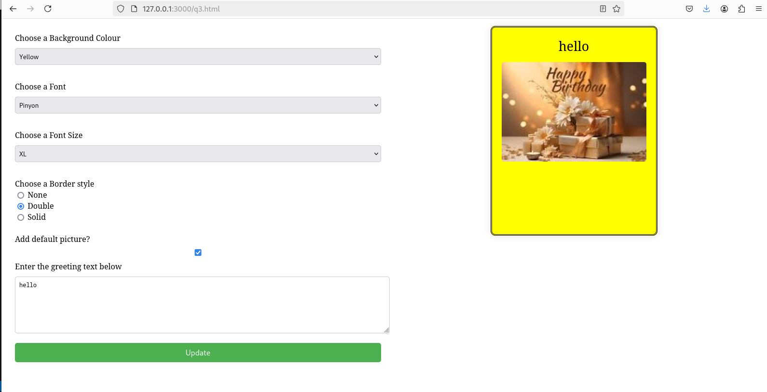

Q4.
<!DOCTYPE html>
<html lang="en">
<head>
<meta charset="UTF-8">
<meta name="viewport" content="width=device-width, initial-scale=1.0">
<title>Product Bill</title>
<style>
body {
font-family: Arial, sans-serif;
text-align: center;
margin-top: 50px;
}

.container {
width: 300px;
margin: auto;
padding: 20px;
border: 2px solid #ccc;
border-radius: 10px;
box-shadow: 0px 0px 15px rgba(0, 0, 0, 0.1);
}

select, input[type="text"], input[type="checkbox"] {
width: 100%;
padding: 8px;
margin: 10px 0;
border-radius: 5px;
border: 1px solid #ccc;
}

button {
padding: 10px 20px;
font-size: 16px;
cursor: pointer;
background-color: #4CAF50;
color: white;
border: none;
border-radius: 5px;
width: 100%;
margin-top: 10px;
}

button:hover {
background-color: #45a049;
}

.result {
margin-top: 20px;
font-size: 18px;
}
</style>
<script src="https://code.jquery.com/jquery-3.6.0.min.js"></script>
<script>
$(document).ready(function() {
$('#produceBillButton').click(function() {
// Get selected brand and product type
var selectedBrand = $('#brandDropdown').val();
var quantity = $('#quantityTextbox').val();
var productType = [];

// Get checked product types
$('input[name="product"]:checked').each(function() {
productType.push($(this).val());
});

// Check if quantity is a number
if (isNaN(quantity) || quantity <= 0) {
alert("Please enter a valid quantity.");
return;
}

// Prepare the bill summary
var bill = "Bill Summary: <br><br>";
bill += "Brand: " + selectedBrand + "<br>";
bill += "Quantity: " + quantity + "<br>";
bill += "Product Type: " + (productType.length > 0 ? productType.join(", ") : "None selected") + "<br>";

// Display the result
$('#result').html(bill);
});
});
</script>
</head>
<body>

<div class="container">
<h2>Generate Bill</h2>
<!-- Dropdown for brand selection -->
<label for="brandDropdown">Select Brand:</label>
<select id="brandDropdown">
<option value="HP">HP</option>
<option value="Nokia">Nokia</option>
<option value="Samsung">Samsung</option>
<option value="Motorola">Motorola</option>
<option value="Apple">Apple</option>
</select>

<!-- Checkboxes for product selection -->
<label>Select Product Type:</label><br>
<input type="checkbox" name="product" value="Mobile"> Mobile<br>
<input type="checkbox" name="product" value="Laptop"> Laptop<br>

<!-- Textbox for entering quantity -->
<label for="quantityTextbox">Enter Quantity:</label>
<input type="text" id="quantityTextbox" placeholder="Enter Quantity">

<!-- Button to produce bill -->
<button id="produceBillButton">Produce Bill</button>

<!-- Display Bill Summary -->
<div class="result" id="result"></div>
</div>

</body>
</html>

